━━━━━━━━━━━━━━━━━━━━━━━━━━━━━━━━━━━━━━━━

ANNUAL SALES
PERFORMANCE REPORT
2024

Consolidated Regional Sales Analysis • Strategic Insights
━━━━━━━━━━━━━━━━━━━━━━━━━━━━━━━━━━━━━━━━

Prepared: June 13, 2026
Classification: Confidential
For Management Review Only

Table of Contents

1. Executive Summary
2. Performance Dashboard
3. Regional Revenue Analysis
4. Market Share Overview
5. Growth Trends
6. North Region
7. South Region
8. East Region
9. West Region
10. Central Region
11. Key Findings
12. Strategic Recommendations

1. Executive Summary

This report presents a comprehensive analysis of the company's sales performance across all major operating regions for the fiscal year 2024. The objective is to provide management with actionable insights into regional performance trends, growth opportunities, and areas requiring strategic attention.
Sales increased in several regions while some regions experienced slower growth. Management requested a consolidated report to review trends and opportunities across the full portfolio. This document consolidates data from all seven regions, analyzing key performance indicators and identifying cross-regional patterns that inform the strategic recommendations outlined in the final section.
$27.0M  Total Q4 Revenue  +11.2% YoY | 18.2%  Operating Margin  +2.1 pp | 5  Regions Analyzed  Nationwide | 16.8%  Best Growth Rate  West Region

The findings indicate strong overall growth momentum, with particular strength in the West and South regions. The North and Central regions present targeted improvement opportunities that, if addressed, could unlock significant additional revenue.

2. Performance Dashboard

Key performance indicators across all operating regions for Q4 2024.
$27.0M  Consolidated Revenue  Q4 2024 Total | 11.2%  Avg. YoY Growth  Company-Wide | 26.4%  Highest Market Share  West Region
5.2%  Improvement Target  Central Region | 4.6/5.0  Customer Satisfaction  South Region | 45%  E-Commerce Growth  West Region YoY

Regional Goal Achievement
Progress toward FY 2024 revenue targets by region:
Region | Progress | Achievement
West | ██████████████████░░ | 92%
South | █████████████████░░░ | 88%
East | ███████████████░░░░░ | 79%
North | ██████████████░░░░░░ | 71%
Central | ███████████░░░░░░░░░ | 58%

3. Regional Revenue Analysis

The bar chart below illustrates Q4 2024 revenue performance across all five operating regions. The West region leads with $7.3M in revenue, followed closely by the South at $6.8M. Together, these two regions account for over half of total company revenue.
Chart 1: Q4 2024 Revenue by Region (USD Millions)
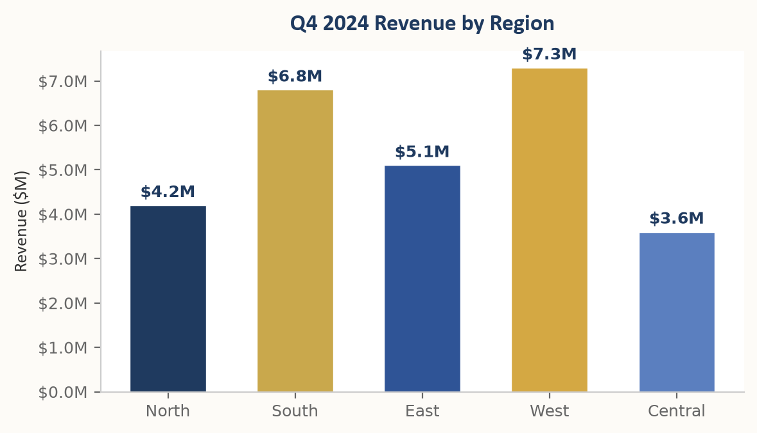

Revenue Breakdown by Region
Region | Q4 Revenue | YoY Growth | Market Share | Status
West | $7.3M | +16.8% | 26.4% | Exceeding
South | $6.8M | +14.2% | 24.6% | Exceeding
East | $5.1M | +11.3% | 20.1% | On Track
North | $4.2M | +8.5% | 18.2% | On Track
Central | $3.6M | +5.2% | 10.7% | Attention
Total | $27.0M | +11.2% | 100% | ●

4. Market Share Overview

The West and South regions together command 51% of total company revenue. The pie chart below illustrates the market share distribution across all operating regions.
Chart 2: Market Share Distribution by Region
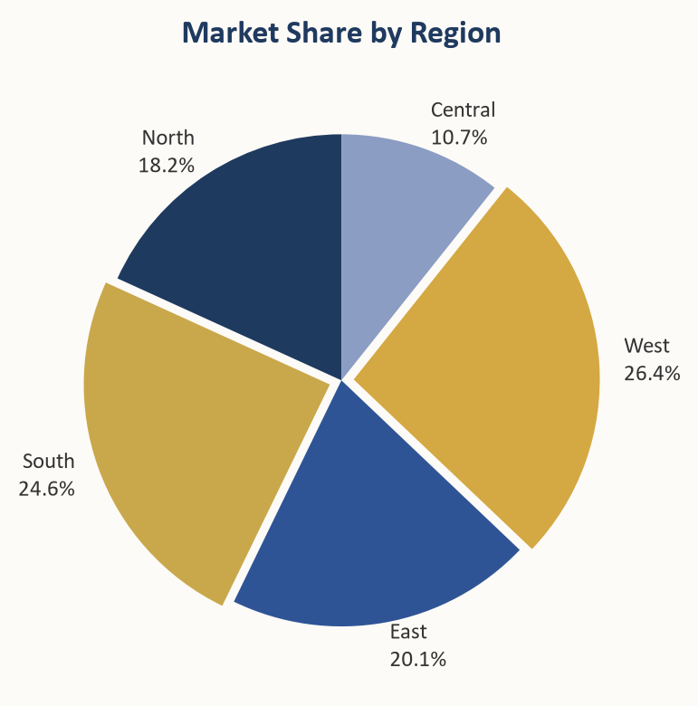
The West region holds the largest share at 26.4%, followed by the South at 24.6%. The Central region, while smallest at 10.7%, represents a significant growth opportunity.

5. Growth Trends

Year-over-year growth rates vary significantly across regions. The company-wide average of 11.2% was exceeded by the West (+16.8%) and South (+14.2%) regions. The dashed gold line indicates the company average benchmark.
Chart 3: Year-over-Year Growth Rate by Region (%)
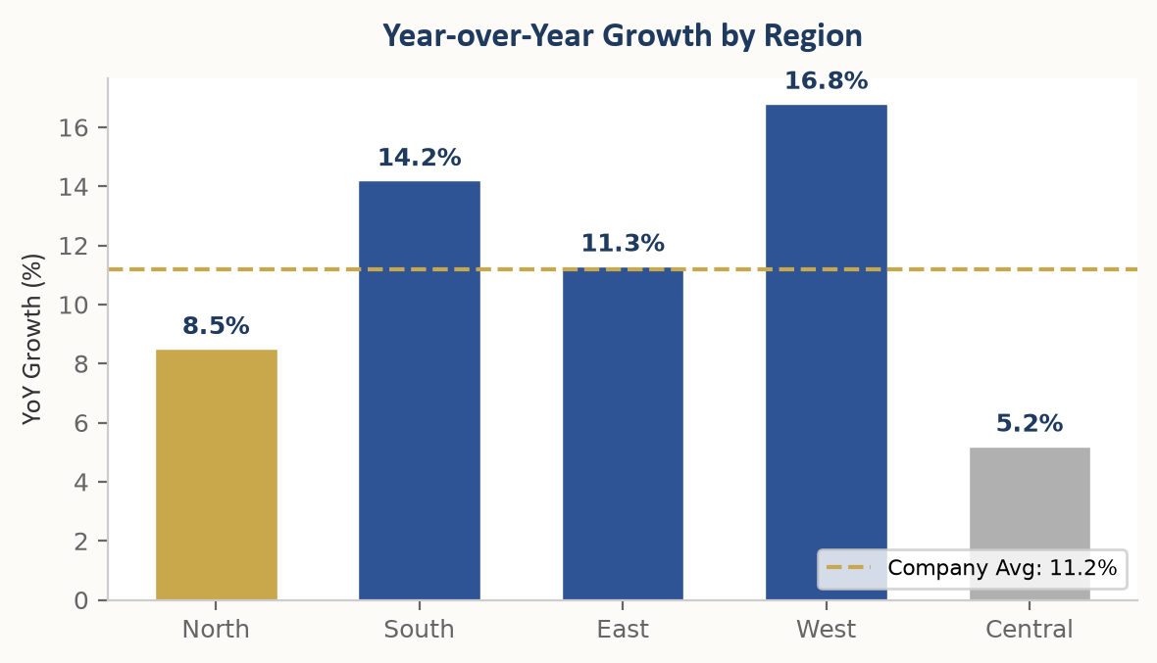
Key observation: Three regions (West, South, East) outperformed or matched the company average, while North and Central regions fell below the benchmark. Targeted interventions for these regions could unlock an estimated $2-3M in additional annual revenue.

6. North Region Analysis

$4.2M  Q4 Revenue | +8.5%  YoY Growth | 18.2%  Market Share | 71%  Goal Achieved

The North region demonstrated stable growth throughout FY 2024, with quarterly revenue increasing steadily across all four quarters. Sales increased in several sub-regions while some areas experienced relatively slower growth. Management has identified targeted opportunities to accelerate momentum through expanded distribution channels and enhanced local marketing initiatives.

Key Highlights
- Q4 revenue of $4.2M representing 18.2% of total company revenue
- Year-over-year growth of 8.5%, below company average of 11.2%
- Customer acquisition cost reduced by 6% through digital channel optimization
- Two new distribution partnerships established in Q3

Goal Achievement
North Region | ██████████████░░░░░░ 71%

7. South Region Analysis

$6.8M  Q4 Revenue | +14.2%  YoY Growth | 24.6%  Market Share | 88%  Goal Achieved

The South region was among the strongest performers this year, posting double-digit growth and expanding market share. Sales increased significantly across most product lines, driven by successful promotional campaigns and strong customer retention. The region's performance exceeded internal targets and contributed meaningfully to overall corporate results.

Key Highlights
- Q4 revenue of $6.8M — 24.6% of total company revenue (highest share among all regions)
- Year-over-year growth of 14.2%, well above company average
- Customer satisfaction score improved to 4.6/5.0
- Three major enterprise accounts closed in Q4

Goal Achievement
South Region | █████████████████░░░ 88%

8. East Region Analysis

$5.1M  Q4 Revenue | +11.3%  YoY Growth | 20.1%  Market Share | 79%  Goal Achieved

The East region maintained steady growth throughout the year, with consistent quarter-over-quarter improvements. Sales increased in urban markets while rural expansion initiatives began gaining traction in the second half of the year. The region benefited from targeted marketing investments and improved sales team productivity.

Key Highlights
- Q4 revenue of $5.1M representing 20.1% of total revenue
- Year-over-year growth of 11.3%, closely aligned with company average
- Rural market penetration increased by 22% year-over-year
- Sales team productivity improved 15% after new training program

Goal Achievement
East Region | ███████████████░░░░░ 79%

9. West Region Analysis

$7.3M  Q4 Revenue | +16.8%  YoY Growth | 26.4%  Market Share | 92%  Goal Achieved

The West region delivered exceptional performance in FY 2024, achieving the highest growth rate across all regions. Sales increased substantially across both existing and new product categories. The region's success was driven by strong economic conditions, effective sales leadership, and successful market expansion strategies.

Key Highlights
- Q4 revenue of $7.3M leading all regions with 26.4% revenue share
- Year-over-year growth of 16.8% — fastest growing region
- New product lines contributed 28% of regional revenue
- E-commerce channel grew 45%, now representing 32% of regional sales

Goal Achievement
West Region | ██████████████████░░ 92%

10. Central Region Analysis

$3.6M  Q4 Revenue | +5.2%  YoY Growth | 10.7%  Market Share | 58%  Goal Achieved

The Central region showed moderate growth with room for improvement. Sales increased at a slower pace compared to other regions, reflecting both market challenges and internal execution gaps. Management is developing a targeted improvement plan to address the region's performance gap and unlock its full potential.

Key Highlights
- Q4 revenue of $3.6M representing 10.7% of total revenue
- Year-over-year growth of 5.2% — below company average
- Cost optimization initiative identified $420K in annual savings
- New regional director appointed in Q4 to drive turnaround strategy

Goal Achievement
Central Region | ███████████░░░░░░░░░ 58%

11. Key Findings

Strong Overall Growth
The company achieved 11.2% year-over-year revenue growth in FY 2024, driven primarily by strong performance in the West (+16.8%) and South (+14.2%) regions. Total consolidated revenue reached $27.0M for Q4 alone.

Regional Performance Gap
A notable performance gap exists between high-growth regions (West, South) and lower-growth regions (Central at +5.2%). Addressing this disparity represents a significant opportunity for corporate value creation, with an estimated $2-3M in potential upside.

Digital Channel Acceleration
E-commerce and digital channels are becoming increasingly important, with the West region's online channel growing 45% year-over-year. Digital transformation initiatives should be accelerated across all regions to capture this trend.

Market Position Strength
The company maintains strong market positions across all regions, with market share ranging from 10.7% (Central) to 26.4% (West). There is room for share expansion, particularly in the North and Central regions where targeted investments could yield meaningful gains.

Customer Satisfaction Leadership
The South region's customer satisfaction score of 4.6/5.0 demonstrates best-in-class service delivery. Replicating these practices across other regions could improve retention and drive referral-based growth.

12. Strategic Recommendations

Based on the analysis of regional performance data and emerging market trends, management recommends the following strategic actions for FY 2025:

1. Accelerate Digital Transformation
Invest in e-commerce capabilities and digital marketing across all regions, with particular focus on North and Central regions where digital penetration lags behind peers. Target: 30% digital channel contribution by Q4 FY 2025.

2. Regional Turnaround — Central Region
Implement a dedicated growth initiative for the Central region, including leadership changes, targeted marketing investments, and distribution network expansion. Target: achieve 10%+ growth rate by Q2 FY 2025.

3. Scale High-Performance Practices
Document and replicate the successful strategies from West and South regions across the broader organization. Key areas include sales training programs, customer retention frameworks, and promotional campaign templates.

4. Cross-Regional Collaboration
Establish a Regional Excellence Council to facilitate knowledge sharing and best practice transfer between regions. Monthly cross-regional reviews to track progress against targets.

5. Enhance Analytics Capabilities
Deploy advanced analytics tools to provide real-time sales performance dashboards for all regions. Enable predictive forecasting and early warning systems for underperforming segments.

